**Abstract**

Chat bots are computer programs that mimic conversation with people using artificial intelligence. They can transform the way you interact with the internet from a series of self-initiated tasks.

Such programs are often designed to convincingly simulate how a human would behave as a conversational partner, thereby passing the Turing test. Chabot’s are typically used in dialog systems for various practical purposes including customer service or information acquisition. Some chatbots use sophisticated natural language processing systems, but many simpler systems scan for keywords within the input, then pull a reply with the most matching keywords, or the most similar wording pattern, from a database.

**Introduction**

Chat bots are computer programs that mimic conversation with people using artificial intelligence. They can transform the way you interact with the internet from a series of self-initiated tasks.

Such programs are often designed to convincingly simulate how a human would behave as a conversational partner, thereby passing the Turing test. Chabot’s are typically used in dialog systems for various practical purposes including customer service or information acquisition. Some chatterbots use sophisticated natural language processing systems, but many simpler systems scan for keywords within the input, then pull a reply with the most matching keywords, or the most similar wording pattern, from a database.

The term "ChatterBot" was originally coined by Michael Mauldin in 1994 to describe these conversational programs. Today, Chabot are part of virtual assistants such as Google Assistant, and are accessed via many organizations' apps, websites, and on instant messaging platforms such as all. Non-assistant applications include Chabot’s used for entertainment purposes, for research, and social bots which promote a particular product, candidate, or issue.

For example the most common chat bots these days are the Natasha from Hike

Or the Siri from apple phones.

These chat bots help us to design and assist us to help us in which ever field of life we need.

Specialist companies that create chat bots in the travel industry include Digital Genius, Yalochat.com, and Caravelo. In 2017, the Israeli company Snatch bot launched a chat bot creation website, which claimed the capability of building bots with sentiment analysis.

2.1 “Scope of Chat bot”

In the 1950s, Alan Turing dedicated much of his work around machine learning and artificial intelligence. That was nearly *70 years ago*. But until today, we’ve resisted the adoption of artificial intelligence, even though it’s been completely possible.

Maybe it’s because we’re afraid of artificial intelligence. Or maybe it’s because the ones we’ve made aren’t mature enough to handle the complexity our human needs. Whatever the reason for avoiding artificial intelligence, we’ve overcome it.

Chat bots, apps that you interact with via a chat interface, are now among the hottest tech trends of 2017. Here’s why I think it’ll be good for us.

**1. Just because there is an “app for that”, doesn’t mean that we’ll use it. Chat bots will help.**

Here’s the brutal new reality facing the app economy: people are abandoning downloaded apps more than ever.

According to a report by Personetics, “Close to a quarter of all downloaded apps were deleted after just one use. Research shows that most users have just a few applications they use on a regular basis. These are usually the applications that save time or money (or both) and make life easier.”

This has led to what can properly be defined as app fatigue. In even the past 5–7 years, users have already grown tired of bouncing between too many apps or learning how to use a new interface after every new download.

Furthermore, research firm com Score finds that among mobile users surveyed, most spend 85% of their time using email and messaging apps. One of the primary benefits of chat bots is there is no reason to download a new app for every service. A customer can chat with their friends, order food, get a ride with Uber, and transfer money, all without leaving their favourite messaging app.

**2. Chat bots allow us to access all our apps in one program.**

It might be too late to build a software company around a mobile app. If you want to compete in the digital age, you’ll want to build experiences where people are. That place is now inside messenger apps.

“People are now spending more time in messaging apps than in social media and that is a huge turning point. Messaging apps are the platforms of the future and bots will be how their users access all sorts of services.”*— Peter Rojas, Entrepreneur in Residence at Betaworks*

Messaging apps have become *platforms* with iMessage, Facebook Messenger, Google Aloe and many other messaging services providing their own app stores. For example, you can now download Ever note for iMessage or shop right inside of Facebook Messenger.

We are clearly tired of trying new apps and are getting very comfortable in messaging apps. The fundamental idea is that consumers will interact with *just enough* UI to be delighted by a service or product. Anything more feels like a burden.

It’s a total paradigm shift in growth and engagement strategies. Why fight for your attention when I can just deliver my product or service where you already are?

**3. Chat bots will make apps faster and easier to use.**

Think of chat bots like virtual butlers, fetching information like weather and news and doing things like scheduling meetings and buying your groceries for you. If the bot doesn’t immediately understand your intent or doesn’t act fast enough, it could be incredibly frustrating.

But done properly, our mobile experience has such *amazing* potential with catboats. There’s something to be said for accomplishing everything on your phone from one app, especially if it already knows what I want to accomplish.

Chat bots, powered by artificial intelligence and machine learning, can do so much more than mobile applications because it can learn our habits, understands our tastes and preferences and can be much more pleasant than a sequence of taps and clicks to get to where I want to go.

In fact, so many companies will begin to build catboats, that it may make apps and even websites completely obsolete over the next few years. Because the front-end is so light-weight and there’s less friction to accessing information, bots will become *faster* than websites and apps, even customer service call centres.

Imagine texting Nike to track your recent sneaker order rather than opening your browser to log in and stumble around the site to find your order history. Or better yet… Nike texting *you* about shipping updates.

Chabot’s can create such an intimate, personalized customer experience, that brands that don’t embrace the rise of Chabot’s might be left behind.

Software and Hardware Requirements

1. Node.js

Node.js® is a JavaScript runtime built on [Chrome's V8 JavaScript engine](https://developers.google.com/v8/). Node.js uses an event-driven, non-blocking I/O model that makes it lightweight and efficient. Node.js' package ecosystem, [npm](https://www.npmjs.com/), is the largest ecosystem of open source libraries in the world.

1. **MySQL**

MySQL is the most popular Open Source Relational SQL Database Management System. MySQL is one of the best RDBMS being used for developing various web-based software applications.

1. HTML/CSS

**Hypertext Markup Language** (**HTML**) is the standard markup language for creating web pages and web applications. With Cascading Style Sheets (CSS) and JavaScript it forms a triad of cornerstone technologies for the World Wide Web..Web browsers receive HTML documents from a web server or from local storage and render them into multimedia web pages. HTML describes the structure of a web page semantically and originally included cues for the appearance of the document.

1. Rivescript

**RiveScript** is a text-based scripting language meant to aid in the development of interactive chat bots. A chat bot is a software application that can communicate with humans using natural languages such as English in order to provide entertainment, services or just have a conversation.

Database Design

We have created the following tables.

1) Users table

2) Stores table

3) Product table

4) Admin table

Our project basically assist the user to find the grocery items in nearby arrears.

Our virtual chat bot helps the user to find the basic commodities in nearby stores around him.

**System Design**

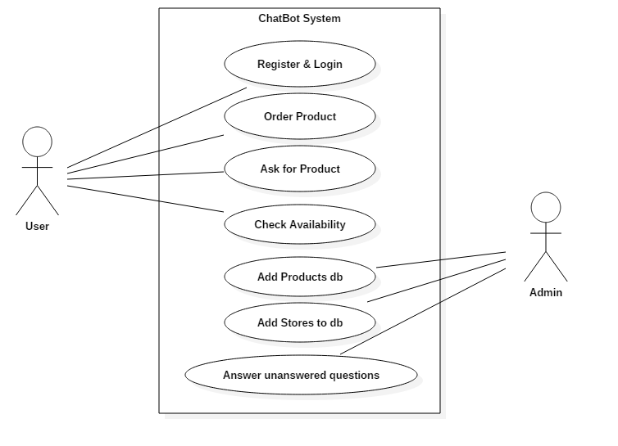

Fig 1. Use Case Diagram

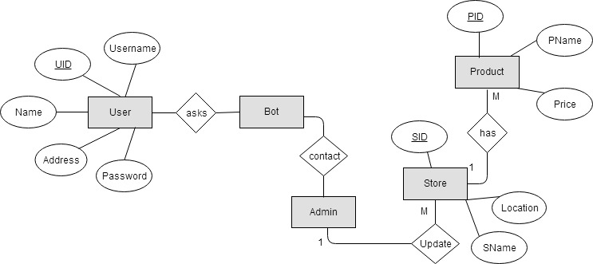

Fig 2. Entity Relationship Diagram

**CMS**

**WordPress**

A content management system or CMS is a software that facilitates creating, editing, organizing, and publishing content. WordPress is a Content Management System that allows you to create and publish your content on the web. Although it is mostly used for web publishing, it can be used to manage content on an intranet, or in a single computer.

WordPress allows users to have full control over the files, documents, as well as the design and display of the content. You don’t have to know a single line of code to publish content using WordPress. The beauty of a good content management system is to allow any user to create and manage their content without any technical know-how.

In the earlier days, an average user or a small company had to rely on static HTML sites because they could not afford a content management system which would cost hundreds of thousands of dollars. That problem is now solved. WordPress is open source and free for anyone to use.

WordPress is being used in all sort of creative ways. We have seen WordPress being used to power small business websites, blogs, large university websites, portfolios, real estate property listing site, internal communication system for companies, web directories, movie databases, application infrastructure base, arcade sites, and basically anything else you can think of.

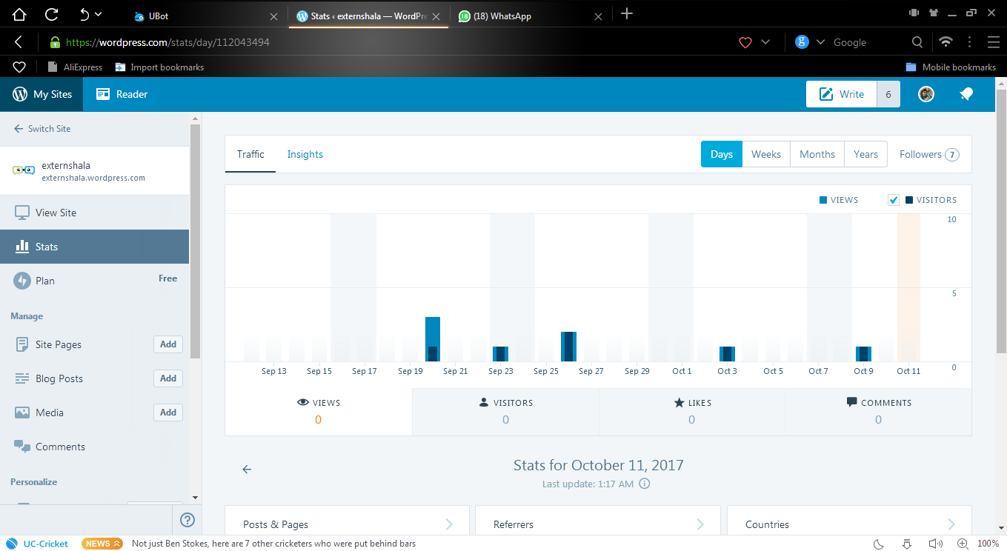

Fig 3. WordPress Dashboard

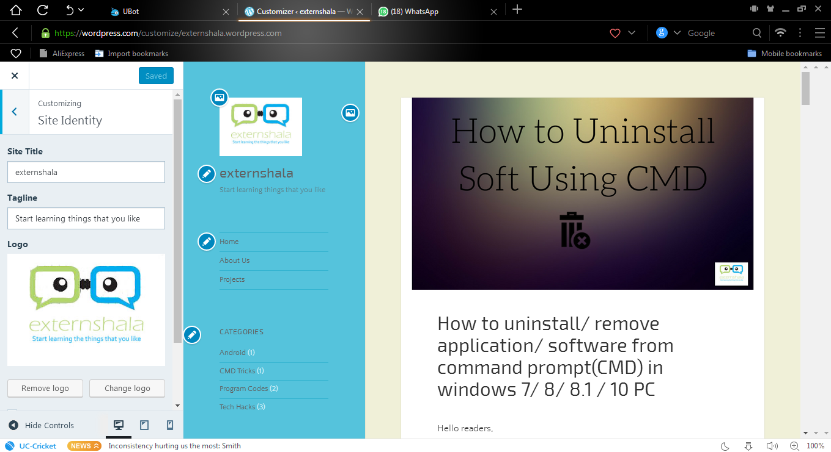

Fig 4. Blog Writing in CMS

**TESTING**

Testing involves operation of a system or application under controlled conditions and evaluating the results. The controlled conditions should include both normal and abnormal conditions. Software quality assurance

Involves the entire software development phases-monitoring and improving the process, making sure that any agreed-upon standards and procedures are followed, and ensuring that problems are found and dealt with SQA is oriented to ‘detection’. We had followed the formal way to test our software to have a quality product. Testing also has its own life cycle. This life cycle involves following steps:

* System understanding
* Proposing testing Types
* Writing Test Plans
* Writing test Scenarios/ Test Cases
* Reporting Defects found
* Wind Up with closure Report

These are the steps, which are followed for manual testing, testing the software with automated tools itself is having another approach and of course it’s own life cycle.

In this we have test near about all the aspect of testing in each software development process. We have covered following testing types with an expectation below:

* User Acceptance Testing
* Code Review/Code Coverage
* Functionality Testing
* Regression Testing
* Smoke Testing
* **User Acceptance System**

User acceptance testing is the final testing based on specifications of the end-user, or based on use by end-user over certain period time, after making a requirement analysis, user Acceptance test plan gets generated. The end user reviews this test plan, this test plan and then after completion of whole application, executes the UAT plan, this document reflects all the requirement of a user and user checks what the developer interpreted. In our system we prepared UAT plan after the design phase because in design phase all the form layouts were prepared and from that form layout UAT plan got designed for all the testing documents, we strictly followed the above format.

* **Code Review**

The purpose of code review is to have a ‘Good Code’. ‘Good code’ is code that works, is bug free, and is readable and maintainable. Here are some rules/ standards.

* Minimizing or eliminate use of global variables.
* Function and good method sizes should be minimized; less than 1000 lines of code are good.
* Organized code for readability; use white spaces generously-vertically
* And horizontally.
* Each line of code should contain 70 characters max length
* One code statement per line
* Coding style should be consistent throughout a program

It also does coverage of the code coverage of code includes:

* Brach coverage
* Statement coverage

In our system, after all coding part got finished then to review it, first we have done a formal walkthrough. In walkthrough the code is reviewed for consistency maintainability and readability. After that detailed code coverage has been done.

* **Functionality Testing**

It is blank box testing to check the core functionality of the application. This test involves integration/system scenario and test cases are executed during this test. It is not based on any knowledge of internal design or code.

Test scenario and testing of each and every control in the system, testing functionality of our system. Scenario means an end-to –end transaction for writing scenario tester should know complete sequence of the feature. Test cases have also written and executed to check the functionality of the system. Before writing test cases and test scenarios we estimated the number if test cases cases and test scenario through system.

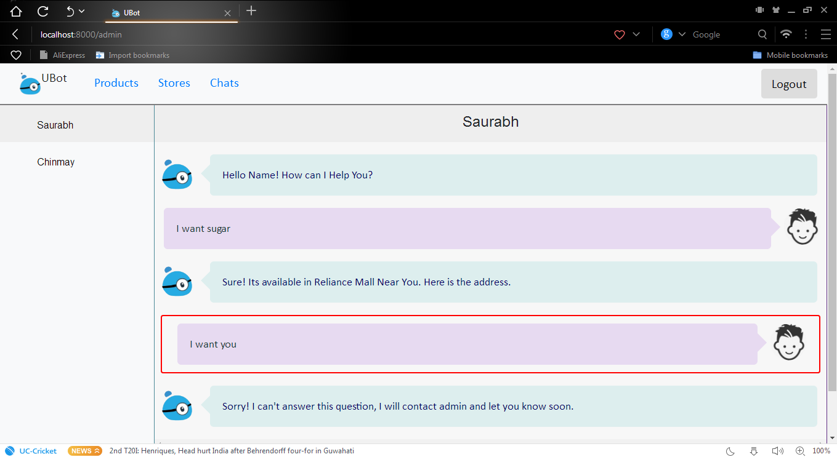

Fig 5. Admin Chats

* **Regression Testing**

Regression test should be carried out after defect fixing or alteration of the software to verify for the fixing of defects and also that no other parts of the software functionality are broken. When defects gets fixed then, the action to fix it may affect other part of the system and so testing whether other parts were affected or not, completes regression testing.

We performed two manual regression rounds. The second regression round was performed because in first round of regression, potential numbers of defects were locked and got fixed afterwards.

* **Smoke Testing**

Purpose of smoke testing is to ensure that the build after first regression defects fixes, is acceptable or not in smoke testing major functionalities are executed and checked whether they cause for system crash or not. If in this testing tester faces system crash then tester rejects that particular build and sends it back to developer.

In our system we performed two rounds of regression testing, smoke test was performed and ensure that application was not crashing and the application is acceptable for second round of regression.

**Outputs**

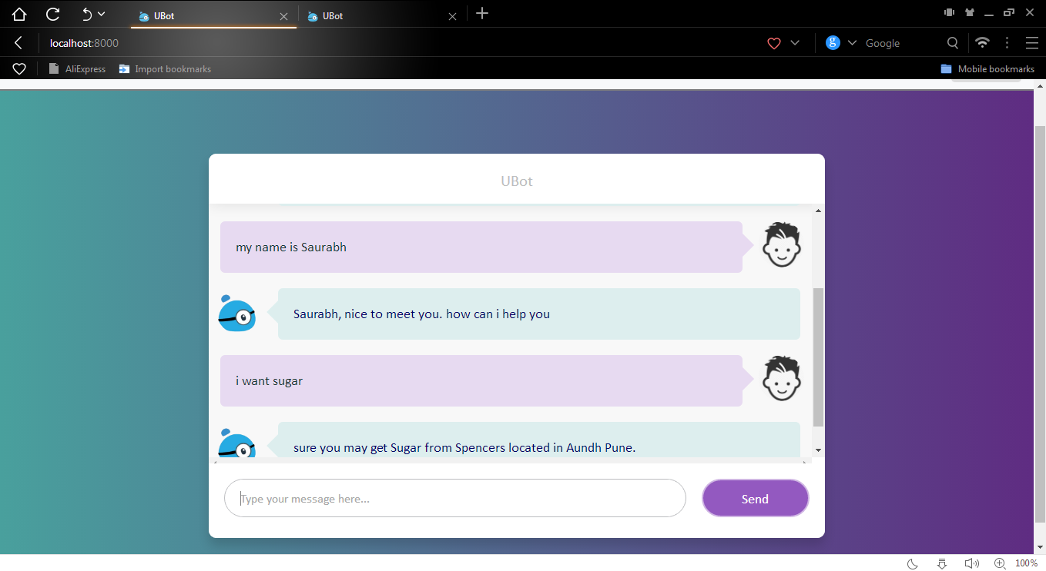

Fig 6. ChatBot Chats

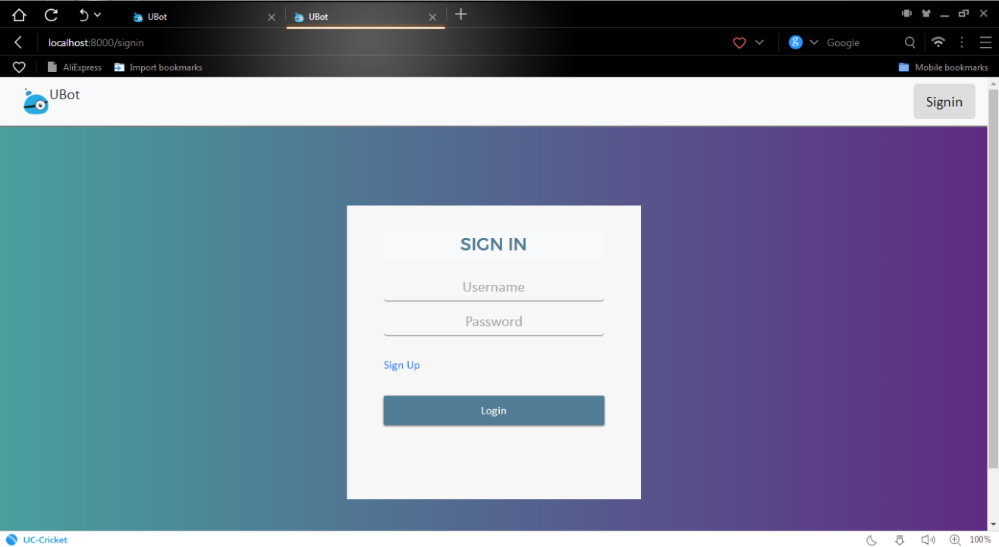

Fig 7. ChatBot Login Page

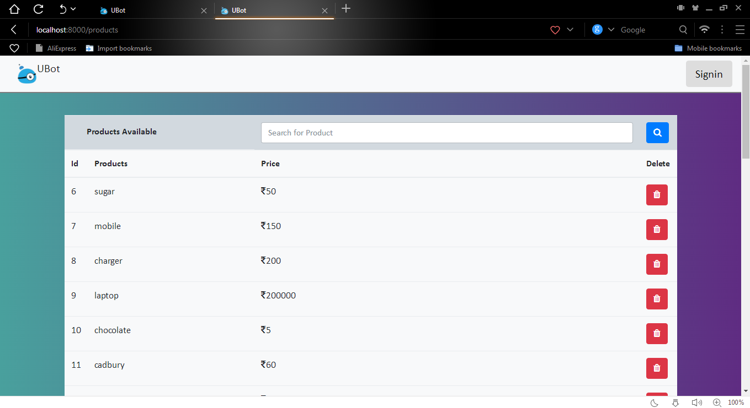

Fig 8. ChatBot Add Products

**CONCLUSION**

Our project is fully compatible with existing system of user which runs on old low configured user machine with faster speed than the previous generation software. So it avoids the replacement of hardware or adding new hardware or updating the system and minimizes cost required for it. Due to purely Object Oriented Language Java used as programming language so response time is decreased. Also system supports all Object Oriented features, supports stronger security.

It’s also provides following:

* The System is user friendly.
* The System very easy to use.
* The System has good GUI.
* The System is secure.
* The user can generate report.

**REFERENCES**

To achieve the success of this “Chat Bot for Store” project we have taken the reference of following books and websites.

**REFERANCE BOOK: -**

* THE COMPLETE REFERENCE Node.js

Author: - Herbert Schildt

* Diploma in Computer Technology Digital Technic.

Author: - J. S. Katre

* Reference for Software Engineering (Testing).

Author: - K.S.Wagh, Mr.swapnil S.shinde

* Reference from Object Oriented Modeling (for designing).

Author: -Mr.Yogesh Kapure, Mrs.Gauri Yogesh Kapure.

**WEBSITES : -**

http://www.nodejs.co.in

http://www.wikihow.com

http://www.w3school.com

<http://www.tutorialspoint.com>

http://www.coders.com

http://www.stackoverflow.com